Precalculus AI Lab
  - Electric vs gas-powered car?
Mathematics Consortium Working Group https://mcwg.github.io
2025

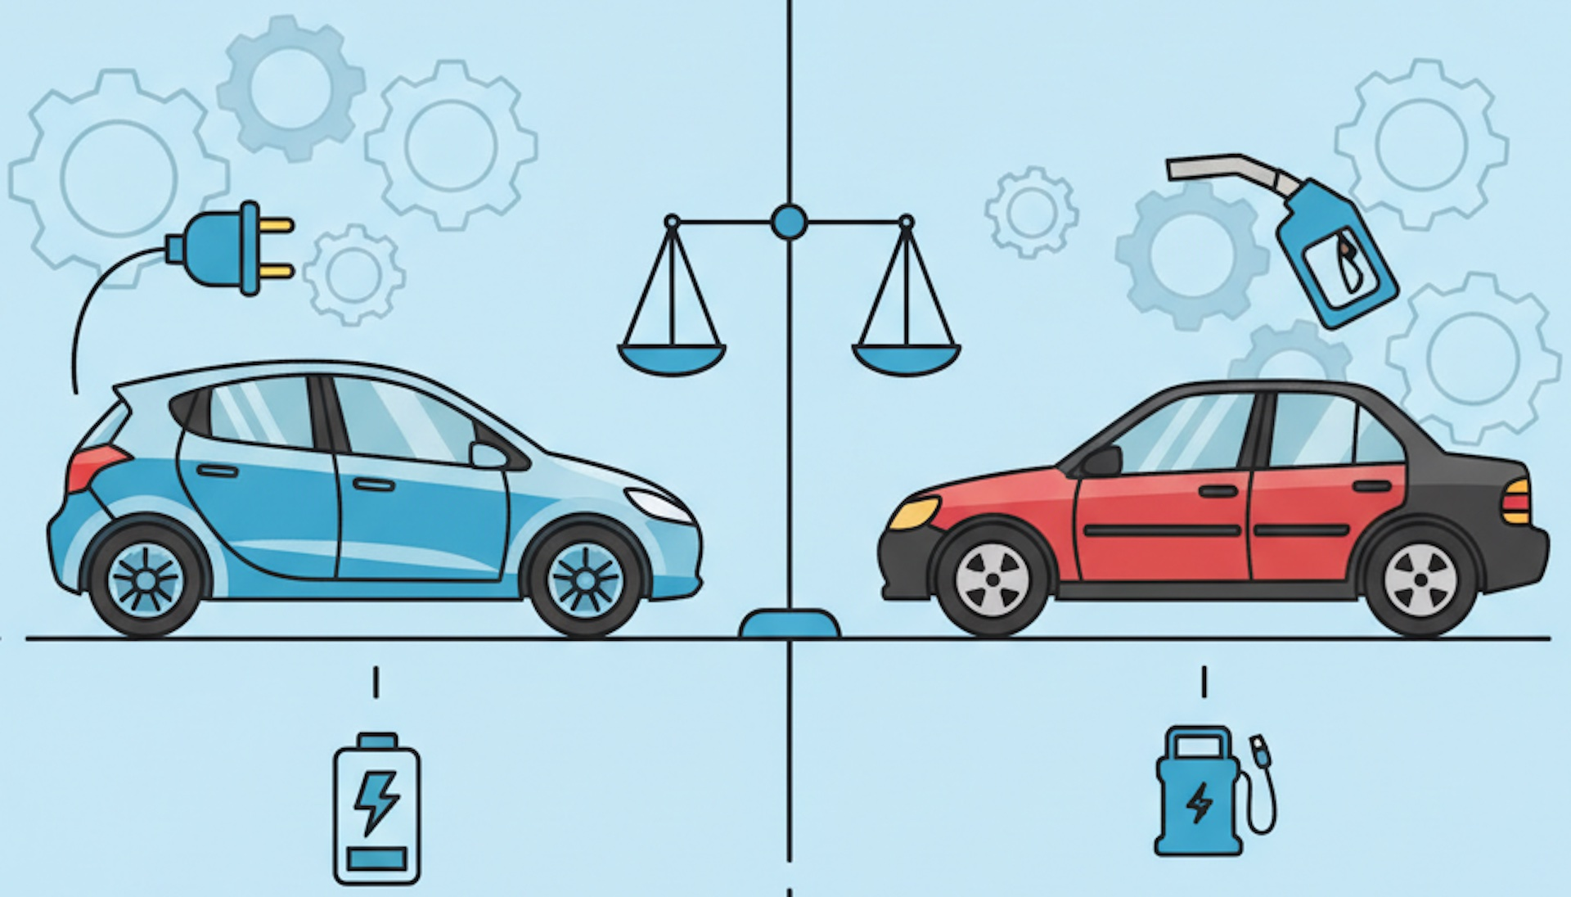
Image generated with nano banana.
In this Lab you will write Python code and run it. You can write the code yourself or get an LLM to do it. Run the code in Google Colab. If it does not run correctly, rewrite until it works correctly.

Purpose of Lab
- Create a model with a linear function.
- From the graph of two functions $f$ and $g$, approximate the solution to $f=g$.
- Interpret the slope of a linear function as rate of change.
- Interpret the meaning of the vertical intercept in context.

Context for Lab
When you think about buying a car, one consideration is the cost of owning the car. Since the purchase prices of gas and electric cars are different, as are the prices of gas and electricity, understanding how these parameters affect the cost of owning a car can help you decide. In this lab, we focus on the purchase costs and fuel to make a simple model, ignoring any differences in maintenance or insurance costs, for example.

Part 1: Modeling the cost of owning an electric car
In Oklahoma in August 2025, you could buy a used electric Mini Cooper for about $20,000 (for a 4-year old car with about 50,000 miles on the odometer). The cost of electricity for the Mini is about 4 cents per mile.
Use an LLM
Generate Python code to sketch an interactive graph of the cost of owning an electric Mini as a function of miles traveled. We ask the LLM to ensure the following:
- The code is simple, easy to follow for a Precalculus student, and runs in Colab.
- Units of the vertical axis are dollars
- Units of the horizontal axis are miles
- The graph is interactive so you can trace over it and be given coordinates of points on the graph, as well as the slope
- The code uses the Plotly library for the interactive graph.
The graph we get is the following with code given at the end of the lab.
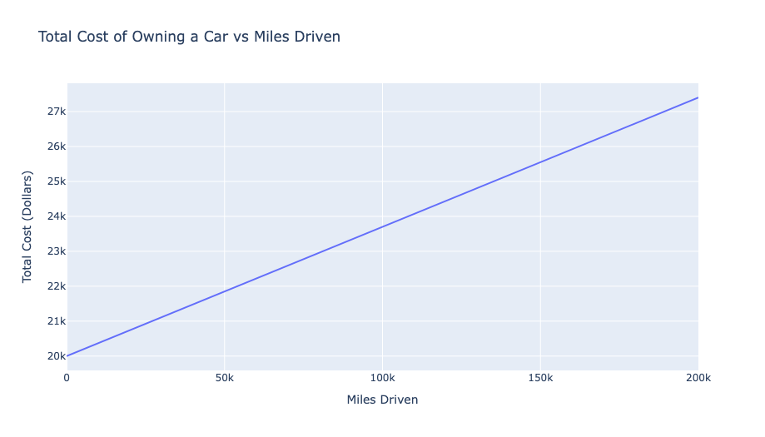
Answer the following questions:
- What is the vertical intercept of the graph? What does that number mean?
- What is the slope of the graph? What does that number mean? How is it related to the information given about the Mini?
- Write the formula for a function $f(d)$ that gives the cost of buying the Mini and driving it $d$ miles. Is your formula in slope intercept form? Why does that make sense?
- How much does it cost to buy the car and drive it 50,000 miles?

Part 2: Comparing the cost of owning an electric car and a gas-powered car
In Oklahoma in August 2025, you could buy a gas-powered Honda Civic for about $17, and operate it for about 8 cents per mile.
Use an LLM
Generate Python code to create a graph that gives the cost of owning the Civic and the cost of owning the Mini (as a function of miles driven) on the same graph.
Use the graph (modify it with the LLM if needed) to answer the following questions:
- What is the cost of owning the Civic if you drive it 25,000 miles? The Mini?
- What does it mean for the lines in your graph to cross?
- At what number of miles is the cost the same for either car?
- How many times do the lines in your graph cross?
- If you drive more miles than your answer to 3, which car is cheaper? Does that change if you drive 100 more miles or 100,000 more?
- Suppose gas prices fall, so the cost of operating the Civic decreases to 6 cents per mile. Modify your code to reflect the change. How does the change in price modify the number of miles driven at which the cost is the same for the Civic and the Mini?

Part 3: Pick your own cars
In this part, pick two cars, one electric and one gas-powered. You could use cars that you might actually be able to buy or cars that you wish you could have.
Answer the following questions:
- What is the purchase price of each car that you chose in your area?
Use an LLM
- Find the cost of operating each car in your area (make sure to check that the LLM is doing something sensible in finding its numbers).
- Make a graph showing the cost of owning each car as a function of the miles driven as you did in Part 2.
- Do the graphs cross for $d>0$? If so, at what point? What does that mean? If not, what does that mean?
- How can you tell only from the slope and the vertical intercept of each graph that the graphs are going to cross for $d>0$? Write the formulas for functions $g(d)$ and $h(d)$ that describe the cost of buying each car and driving it d miles and use the formulas to verify your answer.
- Suppose you want to convince someone to buy an electric car, but you don’t know if they drive just a few miles a year or a lot. What characteristics of the purchase price and cost of driving the car would you want for the cars in your example? What would that mean about the slope and vertical intercept of the functions describing the cost of buying each car and driving it $d$ miles?

Further discussion
- Ask the LLM to walk you in all detail through the math it did to find the intersection point of the two lines in the code and then ask it to show you where that math is used in the code. Before doing so, make sure the code LLM is using $d$ as the distance driven so that you can follow the math. Also, make sure you tell it you are a precalculus student and want to learn, so that it does not use any fancy math.
- Provide an explanation in your own words of how the python code figures out the coordinates of the intersection point of the two lines to display them in the graph.
- You have two cars to consider in the same way you did above.
  - What is the shape of the graph of the cost of owning each car in terms of the number of miles driven?
  - Can there be no break-even points? (points at which both cars cost the same.) If so, how?
  - Can there be more than one break-even point?
  - If there are break-even points, it must be because the cheaper-to-buy car has more expensive operating costs per mile. Explain why.
  - What happens to the break-even point(s) if the cost of the cheaper car becomes more expensive to buy? If the pricier car becomes more expensive to buy? Explain geometrically using the graphs.
  - What happens to the break even point if the operating cost per mile of the more expensive car increases? decreases? Explain geometrically using the graphs.

Sample Python Code
import plotly.graph_objs as go
import numpy as np
# Constants
purchase_cost = 20000 # dollars
operating_cost_per_mile = 0.037 # dollars per mile
# Miles range
miles = np.linspace(0, 200000, 1000)
total_cost = purchase_cost + operating_cost_per_mile * miles
# Numerical slope (derivative) using numpy gradient
slope = np.gradient(total_cost, miles)
# Create figure
fig = go.Figure()
fig.add_trace(go.Scatter(
x=miles,
y=total_cost,
mode='lines',
name='Total Cost',
hovertemplate=(
'Miles: %{x:.0f}<br>'
'Cost: $%{y:.2f}<br>'
'Slope: $%{customdata:.4f} per mile<extra></extra>'
),
customdata=np.round(slope, 6).reshape(-1, 1) # Attach slope to each point
))
# Layout
fig.update_layout(
title='Total Cost of Owning a Car vs Miles Driven',
xaxis_title='Miles Driven',
yaxis_title='Total Cost (Dollars)',
hovermode='x',
)
# Show figure
fig.show()

